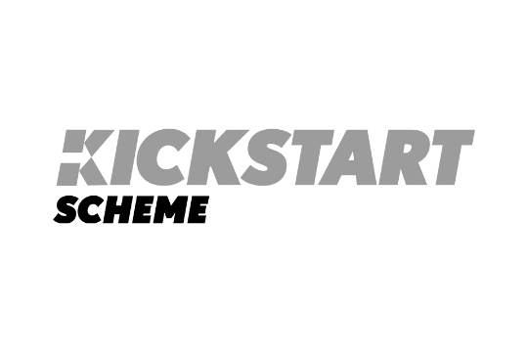
Kickstart Scheme
Kickstart is the UK Government scheme providing funding to employers to create new 6-month job placements for 16 to 24-year-olds who are currently on Universal Credit and at risk of long-term unemployment.
Funding covers 100 per cent of the National Minimum Wage for 25 hours a week and employer National Insurance and minimum automatic enrolment pension contributions as well as extra funding to support the young person to develop the skills and experience they need to find work after completing the placement.
Kickstart is coming to Inverclyde through a partnership between Inverclyde Chamber and CVS Inverclyde. Pooling our experience, we will bid for placements on behalf of Inverclyde businesses and third sector organisations and help with skills and training support throughout the placement.
Roles should be a minimum of 25 hours a week for six months and pay at least the National Minimum Wage for the person's age group. The roles should not require people to undertake extensive training before they begin and they must be new jobs, not replacing an existing job or planned vacancy or cause an existing employee or contractor to lose or reduce their employment.
Placements would be provided from November 2020 to December 2021.
To register your interest, please complete this form and we will be in touch to discuss the details. Completing this form does not mean you must provide the placement; it is just the start of the process as we consider and collate a bid from Inverclyde.
This should be completed and sent to ICC Director, Andrew Bowman at andrew@arbgrowth.co.uk.
Business or charity name:

Address:

Website:

Business Registration Number/Charity Number (if applicable):

Current number of employees:

Contact name:

Contact job title:

Phone number:

Email

Number of kickstart job placements you'd like to create:

For each role please fill out the following:

Job title:

Hours per week:

Wage Rate:

Start Date:

Duration:

Job title:

Hours per week:

Wage Rate:

Start Date:

Duration:

Job title:

Hours per week:

Wage Rate:

Start Date:

Duration:

