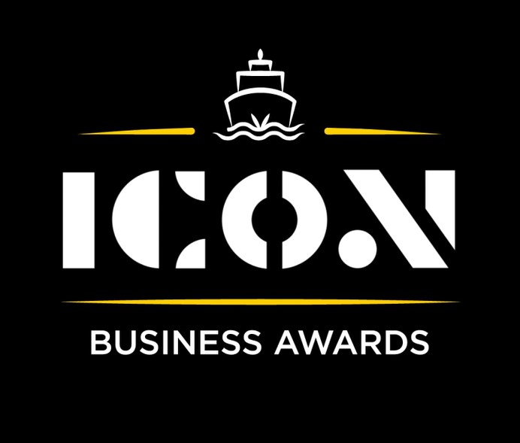

**Business Resilience**



Sponsored by:

Please read the conditions of entry and guidance notes carefully before completing this form.

**Closing date: Midnight 31st May 2024**

**Business Resilience Award**

This award is intended for those organisations that have shown a defiance and resilience in spite of the most challenging trading conditions in many generations. It may be a charity responding to the needs of local people, a business response to the community need or the retention of staff throughout recent difficult periods.

**Who should enter?**

Open to any organisations registered and operating within Inverclyde that have demonstrated an ability to withstand today’s challenging economic climate.

**What are the judges looking for?**

* Businesses who have successfully adapted to meet the challenges of today’s economic climate to both thrive and grow.
* Businesses who have been able to withstand economic downturns.
* Proven examples of how the organisation has bounced back quickly from disruptions, whether from economic crises, supply chain issues, or unexpected events.
* Businesses with the ability to foresee potential risks and take proactive measures to mitigate them.

**INFORMATION FOR APPLICANTS AND TERMS & CONDITIONS**

By submitting this form, you are confirming that you are the person submitting this entry, and that, to the best of your knowledge, the information provided in this form is true and complete.

By submitting this form, you also agree that information from this application can be used for publicity purposes and can be accessed by our Board and sponsors (unless non-publicly available details have been specifically and clearly marked).

* **All fields are compulsory.**
* Please pay attention to word count limits.
* Don't use jargon or acronyms/abbreviations.
* Applicants can apply for up to 3 different categories; however, a separate application form must be completed for each category.
* Membership of the Inverclyde Chamber of Commerce is not a prerequisite for entry to ICON Business Awards and all categories are open to any Inverclyde Business.
* All entries must be submitted by Midnight on Friday 31st May. Entries after this time will not be considered.

If you have any questions regarding the completion of any aspect of the required information please contact Jenna at [marketing@inverclydechamber.co.uk](mailto:marketing@inverclydechamber.co.uk)

**Business Resilience Award**

|  |  |  |  |
| --- | --- | --- | --- |
| **Section 1** | | | |
| **\*Full name of company:** | | | **\*Date company was established:** |
| **\*Business address:** | | | |
| **\*Contact Name:** | | | |
| **\*Position:** | | | |
| **\*Tel:** | **\*Email:** | **\*Web:** | |
| **\*Company Size:** | | | |
| **\*Brief description of the organisation / what you do** | | | |
| **\*Brief description of main products and services** | | | |
| **\*Briefly, what is your vision, strategy and key objectives?** | | | |

|  |
| --- |
| **Section 2** |
| **\*Please supply a supporting statement (300 words or less) on why you believe your company should be shortlisted for this ICON Award category. Please be descriptive and specific:** |
| **\* Can you provide examples of how your business has demonstrated adaptability to overcome challenges in today's economic climate, particularly during periods of economic downturn? (300 words max)** |
| **\*** **Can you provide an example of a significant setback your business experienced and how you bounced back? (300 words max)** |
| **\*** **How do you anticipate and prepare for potential future challenges in the economic landscape, and what strategies do you have in place to mitigate their impact on your business operations? (300 words max)** |

|  |  |
| --- | --- |
| **Section 3** | |
| Authorisation: I have read and accepted the rules and guidelines associated with these awards, and enter this submission on my organisation's behalf. | |
| **\*Name** |  |
| **\*Title** |  |
| **\*Signature** |  |

**What Happens Next?**

Entries will close at Midnight on Friday 31st May

Following this, every application received in each category will be scrutinised by our panel of judges made up of representatives from the award sponsors and ICC Board members, who are well respected in their field.

From this process, a shortlist of 2 entrants in each category will be selected and will be announced and notified on Wednesday 12th June.

After the shortlist is announced, there will be a final deliberation to determine the category winner, who will be announced at the awards ceremony.

Both finalists in each category will receive 2 free tickets to the ICON Awards Ceremony, with additional seats available to purchase.

The ICON Awards Ceremony will take place on 20th September 2024, good luck!

Tickets on sale now!!