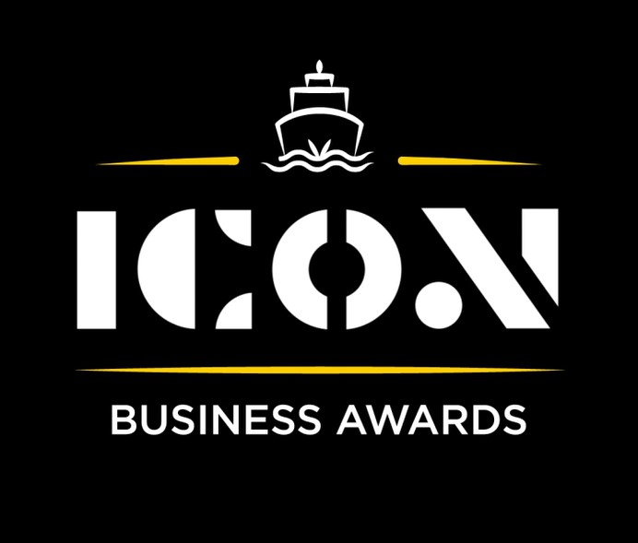

**Internationalism**



Sponsored by:

Please read the conditions of entry and guidance notes carefully before completing this form.

**Closing date: Midnight 31st May 2024**

**Internationalism Award**

This category shines a light on those that are trading internationally across the globe and continues to grow in light of successes and the strong business plans actioned by the company.

**Who should enter?**

Open to all organisations registered in the Inverclyde area.

**What are the judges looking for?**

Judges are seeking businesses who:

* Have demonstrated success in entering and growing in international markets.
* Apply unique strategies or methods to break into new international markets.
* Have a clear and effective business strategy for international expansion.
* Show resilience in overcoming common challenges faced in international business, like navigating regulations, handling logistics, or addressing cultural barriers.
* Serve as role models for other businesses in the Inverclyde area interested in international trade.

**INFORMATION FOR APPLICANTS AND TERMS & CONDITIONS**

By submitting this form, you are confirming that you are the person submitting this entry, and that, to the best of your knowledge, the information provided in this form is true and complete.

By submitting this form, you also agree that information from this application can be used for publicity purposes and can be accessed by our Board and sponsors (unless non-publicly available details have been specifically and clearly marked).

* **All fields are compulsory.**
* Please pay attention to word count limits.
* Don't use jargon or acronyms/abbreviations.
* Applicants can apply for up to 3 different categories; however, a separate application form must be completed for each category.
* Membership of the Inverclyde Chamber of Commerce is not a prerequisite for entry to ICON Business Awards and all categories are open to any Inverclyde Business.
* All entries must be submitted by Midnight on Friday 31st May. Entries after this time will not be considered.

If you have any questions regarding the completion of any aspect of the required information please contact Jenna at [marketing@inverclydechamber.co.uk](mailto:marketing@inverclydechamber.co.uk)

**Internationalism Award**

|  |  |  |  |
| --- | --- | --- | --- |
| **Section 1** | | | |
| **\*Full name of company:** | | | **\*Date company was established:** |
| **\*Business address:** | | | |
| **\*Contact Name:** | | | |
| **\*Position:** | | | |
| **\*Tel:** | **\*Email:** | **\*Web:** | |
| **\*Company Size:** | | | |
| **\*Brief description of the organisation / what you do** | | | |
| **\*Brief description of main products and services** | | | |
| **\*Briefly, what is your vision, strategy and key objectives?** | | | |

|  |
| --- |
| **Section 2** |
| **\*Please supply a supporting statement (300 words or less) on why you believe your company should be shortlisted for this ICON Award category. Please be descriptive and specific:** |
| **\* What strategies did your company implement to successfully break into new international markets? (300 words max)** |
| **\*** **What significant successes have you achieved in international markets, and how did they contribute to your company's growth? (300 words max)** |
| **\*** **What are some key challenges you had to overcome when entering international markets, what did you learn from this? (300 words max)** |
| **\*How do you plan to further leverage your international presence and experience to drive continued growth and expansion for your business? (300 words max)** |

|  |  |
| --- | --- |
| **Section 3** | |
| Authorisation: I have read and accepted the rules and guidelines associated with these awards, and enter this submission on my organisation's behalf. | |
| **\*Name** |  |
| **\*Title** |  |
| **\*Signature** |  |

**What Happens Next?**

Entries will close at Midnight on Friday 31st May

Following this, every application received in each category will be scrutinised by our panel of judges made up of representatives from the award sponsors and ICC Board members, who are well respected in their field.

From this process, a shortlist of 2 entrants in each category will be selected and will be announced and notified on Wednesday 12th June.

After the shortlist is announced, there will be a final deliberation to determine the category winner, who will be announced at the awards ceremony.

Both finalists in each category will receive 2 free tickets to the ICON Awards Ceremony, with additional seats available to purchase.

The ICON Awards Ceremony will take place on 20th September 2024, good luck!

Tickets on sale now!!