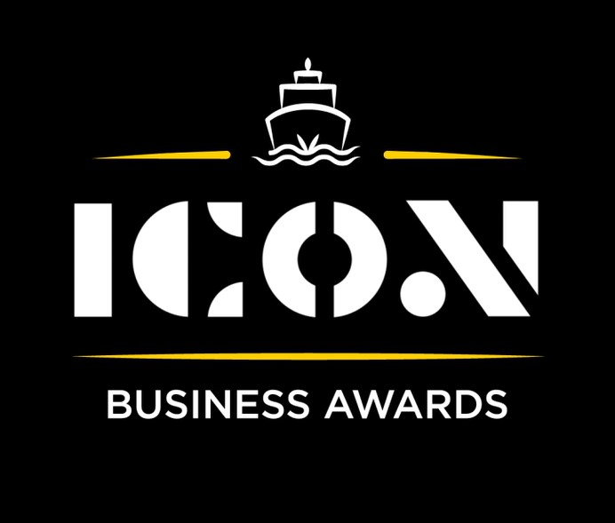

**Rising Star**



Sponsored by:

Please read the conditions of entry and guidance notes carefully before completing this form.

**Closing date: Midnight 31st May 2024**

**Rising Star Award**

This award honours exceptional Inverclyde talent, celebrating the achievements of an individual under 25 who has excelled in their field and made a significant impact on their company's growth and development over the past year.

***Who should enter?***

Open to inspiring young people (**under the age of 25**), whether they be an employee, trainee, graduate or apprentice, within any sector or business. Also open to young business owners and entrepreneurs.

**What are the judges looking for?**

* Individuals with innovative ideas and the ability to bring them to life, whether through their own ventures or within a business setting.
* Individuals who have played a significant role in driving growth and success within a business environment.
* Individuals who demonstrate leadership qualities and make a positive impact on their teams or workplaces.

**INFORMATION FOR APPLICANTS AND TERMS & CONDITIONS**

By submitting this form, you are confirming that you are the person submitting this entry, and that, to the best of your knowledge, the information provided in this form is true and complete.

By submitting this form, you also agree that information from this application can be used for publicity purposes and can be accessed by our Board and sponsors (unless non-publicly available details have been specifically and clearly marked).

* **All fields are compulsory.**
* Please pay attention to word count limits.
* Don't use jargon or acronyms/abbreviations.
* Applicants can apply for up to 3 different categories; however, a separate application form must be completed for each category.
* Membership of the Inverclyde Chamber of Commerce is not a prerequisite for entry to ICON Business Awards and all categories are open to any Inverclyde Business.
* All entries must be submitted by Midnight on Friday 31st May. Entries after this time will not be considered.

If you have any questions regarding the completion of any aspect of the required information please contact Jenna at [marketing@inverclydechamber.co.uk](mailto:marketing@inverclydechamber.co.uk)

**Rising Star Award**

|  |  |  |
| --- | --- | --- |
| **Section 1** | | |
| **\*Full name:** | | |
| **\*Address:** | | |
| **\*Tel:** | **\*Email:** | **\*Web:** |
| **\*Company name:** | | |
| **\*Current position:** | | |
| **\*Brief description of the organisation / what you/they do** | | |
| **\*Brief description of main products and services** | | |

|  |
| --- |
| **Section 2** |
| **\*Please supply a supporting statement (300 words or less) on why you believe you/they should be shortlisted for this ICON Award category. Please be descriptive and specific:** |
| **\*** **How have you/they turned innovative ideas into successful outcomes? Describe a project or idea you implemented and its impact. (300 words max)** |
| **\*** **What specific contributions have you/they made to your company's growth? (300 words max)** |
| **\*** **In what ways have you/they shown leadership and positively influenced your workplace? (300 words max)** |

|  |  |
| --- | --- |
| **Section 3** | |
| Authorisation: I have read and accepted the rules and guidelines associated with these awards, and enter this submission on my organisation's behalf. | |
| **\*Name** |  |
| **\*Title** |  |
| **\*Signature** |  |

**What Happens Next?**

Entries will close at Midnight on Friday 31st May

Following this, every application received in each category will be scrutinised by our panel of judges made up of representatives from the award sponsors and ICC Board members, who are well respected in their field.

From this process, a shortlist of 2 entrants in each category will be selected and will be announced and notified on Wednesday 12th June.

After the shortlist is announced, there will be a final deliberation to determine the category winner, who will be announced at the awards ceremony.

Both finalists in each category will receive 2 free tickets to the ICON Awards Ceremony, with additional seats available to purchase.

The ICON Awards Ceremony will take place on 20th September 2024, good luck!

Tickets on sale now!!