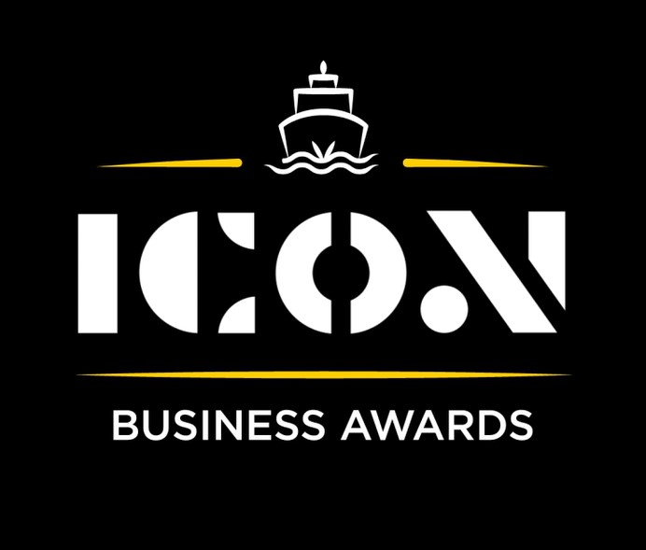

**Skills Development**



Sponsored by:

Please read the conditions of entry and guidance notes carefully before completing this form.

**Closing date: Midnight 31st May 2024**

**Skills Development Award**

This award is intended for organisations that are dedicated to the development of employees/young individual’s/others skills, creating opportunities and a solid framework to support the learning environment.

**Who should enter?**

Any organisation registered in the Inverclyde area that can showcase their commitment to fostering talent, improving workforce capabilities, and driving positive social and economic outcomes through skills development.

**What are the judges looking for?**

* Success in equipping employees/young individuals/other with practical and relevant skills.
* Active engagement of individuals in learning process, fostering a sense of ownership and empowerment.
* Provision of mentorship/training & support services to facilitate skills development and personal growth.
* Tangible outcomes such as improves employability, career advancement or entrepreneurial success.

**INFORMATION FOR APPLICANTS AND TERMS & CONDITIONS**

By submitting this form, you are confirming that you are the person submitting this entry, and that, to the best of your knowledge, the information provided in this form is true and complete.

By submitting this form, you also agree that information from this application can be used for publicity purposes and can be accessed by our Board and sponsors (unless non-publicly available details have been specifically and clearly marked).

* **All fields are compulsory.**
* Please pay attention to word count limits.
* Don't use jargon or acronyms/abbreviations.
* Applicants can apply for up to 3 different categories; however, a separate application form must be completed for each category.
* Membership of the Inverclyde Chamber of Commerce is not a prerequisite for entry to ICON Business Awards and all categories are open to any Inverclyde Business.
* All entries must be submitted by Midnight on Friday 31st May. Entries after this time will not be considered.

If you have any questions regarding the completion of any aspect of the required information please contact Jenna at [marketing@inverclydechamber.co.uk](mailto:marketing@inverclydechamber.co.uk)

**Skills Development Award**

|  |  |  |  |
| --- | --- | --- | --- |
| **Section 1** | | | |
| **\*Full name of company:** | | | **\*Date company was established:** |
| **\*Business address:** | | | |
| **\*Contact Name:** | | | |
| **\*Position:** | | | |
| **\*Tel:** | **\*Email:** | **\*Web:** | |
| **\*Company Size:** | | | |
| **\*Brief description of the organisation / what you do** | | | |
| **\*Brief description of main products and services** | | | |
| **\*Briefly, what is your vision, strategy and key objectives?** | | | |

|  |
| --- |
| **Section 2** |
| **\*Please supply a supporting statement (300 words or less) on why you believe your company should be shortlisted for this ICON Award category. Please be descriptive and specific:** |
| **\*What mentorship, training, and support services does your company offer to facilitate skills development and personal growth? Please describe some of these programs or initiatives in detail: (300 words max)** |
| **\*How does your organisation evaluate the effectiveness of its skills development programs? What metrics or feedback mechanisms are used? (300 words max)** |
| **\*Can you describe a specific success story where an employee or team significantly benefited from your organisation's development programs? (300 words max)** |

|  |  |
| --- | --- |
| **Section 3** | |
| Authorisation: I have read and accepted the rules and guidelines associated with these awards, and enter this submission on my organisation's behalf. | |
| **\*Name** |  |
| **\*Title** |  |
| **\*Signature** |  |

**What Happens Next?**

Entries will close at Midnight on Friday 31st May

Following this, every application received in each category will be scrutinised by our panel of judges made up of representatives from the award sponsors and ICC Board members, who are well respected in their field.

From this process, a shortlist of 2 entrants in each category will be selected and will be announced and notified on Wednesday 12th June.

After the shortlist is announced, there will be a final deliberation to determine the category winner, who will be announced at the awards ceremony.

Both finalists in each category will receive 2 free tickets to the ICON Awards Ceremony, with additional seats available to purchase.

The ICON Awards Ceremony will take place on 20th September 2024, good luck!

Tickets on sale now!!