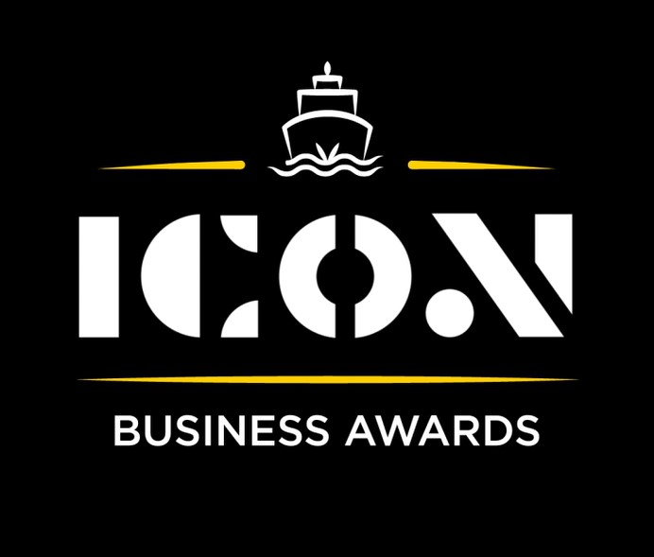

**Sustainability**

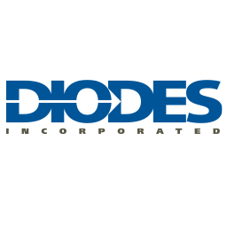

Sponsored by:

Please read the conditions of entry and guidance notes carefully before completing this form.

**Closing date: Midnight 31st May 2024**

**Sustainability Award**

This category recognises excellence in companies of any size that has created business opportunities through its sustainability measures, as well as supporting the environment.

**Who should enter?**

Any Inverclyde based business that manufactures at any scale and within any sector.

**What are the judges looking for?**

* Organisations who can demonstrate a commitment to environmental sustainability.
* Leadership in projects that may for example include savings in CO2 emissions or working towards net zero targets, improved recycling, circular economy, reduced use of hydro carbons, sourcing alternative energy supplies etc.
* Organisations who make a conscious effort to reduce waste, conserve water & promote recycling.

**INFORMATION FOR APPLICANTS AND TERMS & CONDITIONS**

By submitting this form, you are confirming that you are the person submitting this entry, and that, to the best of your knowledge, the information provided in this form is true and complete.

By submitting this form, you also agree that information from this application can be used for publicity purposes and can be accessed by our Board and sponsors (unless non-publicly available details have been specifically and clearly marked).

* **All fields are compulsory.**
* Please pay attention to word count limits.
* Don't use jargon or acronyms/abbreviations.
* Applicants can apply for up to 3 different categories; however, a separate application form must be completed for each category.
* Membership of the Inverclyde Chamber of Commerce is not a prerequisite for entry to ICON Business Awards and all categories are open to any Inverclyde Business.
* All entries must be submitted by Midnight on Friday 31st May. Entries after this time will not be considered.

If you have any questions regarding the completion of any aspect of the required information please contact Jenna at [marketing@inverclydechamber.co.uk](mailto:marketing@inverclydechamber.co.uk)

**Sustainability Award**

|  |  |  |  |
| --- | --- | --- | --- |
| **Section 1** | | | |
| **\*Full name of company:** | | | **\*Date company was established:** |
| **\*Business address:** | | | |
| **\*Contact Name:** | | | |
| **\*Position:** | | | |
| **\*Tel:** | **\*Email:** | **\*Web:** | |
| **\*Company Size:** | | | |
| **\*Brief description of the organisation / what you do** | | | |
| **\*Brief description of main products and services** | | | |
| **\*Briefly, what is your vision, strategy and key objectives?** | | | |

|  |
| --- |
| **Section 2** |
| **\*Please supply a supporting statement (300 words or less) on why you believe your company should be shortlisted for this ICON Award category. Please be descriptive and specific:** |
| **\* How has your business demonstrated a commitment to environmental sustainability, and what specific initiatives have you implemented? (300 words max)** |
| **\*** **What are your organisation's long-term sustainability goals, and how do you plan to achieve them? (300 words max)** |
| **\*** **How do you engage your employees and stakeholders in your sustainability efforts? (300 words max)** |

|  |  |
| --- | --- |
| **Section 3** | |
| Authorisation: I have read and accepted the rules and guidelines associated with these awards, and enter this submission on my organisation's behalf. | |
| **\*Name** |  |
| **\*Title** |  |
| **\*Signature** |  |

**What Happens Next?**

Entries will close at Midnight on Friday 31st May

Following this, every application received in each category will be scrutinised by our panel of judges made up of representatives from the award sponsors and ICC Board members, who are well respected in their field.

From this process, a shortlist of 2 entrants in each category will be selected and will be announced and notified on Wednesday 12th June.

After the shortlist is announced, there will be a final deliberation to determine the category winner, who will be announced at the awards ceremony.

Both finalists in each category will receive 2 free tickets to the ICON Awards Ceremony, with additional seats available to purchase.

The ICON Awards Ceremony will take place on 20th September 2024, good luck!

Tickets on sale now!!