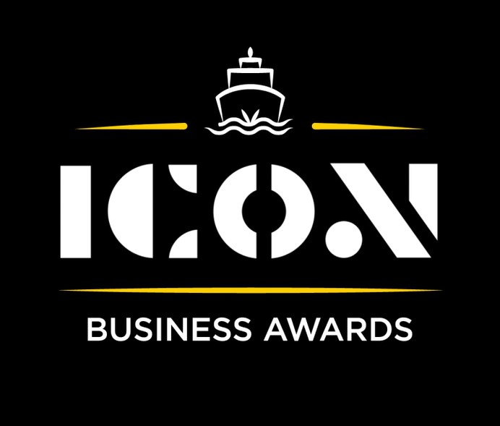

**Tourism**

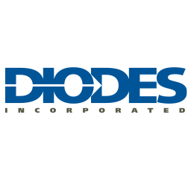

Sponsored by:

Please read the conditions of entry and guidance notes carefully before completing this form.

**Closing date: Midnight 31st May 2024**

**Tourism Award**

This award celebrates the positive contribution of local tourism or hospitality related businesses in encouraging local spend, attracting visitors to the area and enhancing the profile of the Inverclyde area through what they can offer.

**Who should enter?**

Open to any business registered and operating in Inverclyde that welcomes visitors. E.G you may be operating in the hospitality & catering, visitor attraction, leisure, retail or transport sector.

**What are the judges looking for?**

* Businesses that can demonstrate why their business, product, service contribute to Inverclyde’s visitor experience.
* Evidence of how the business contributes to increasing local tourism and attracting visitors to the Inverclyde area.
* Businesses that enhance the profile of Inverclyde through their offerings, events, or promotions.
* Businesses that can demonstrate an impact on the local economy through tourism.
* Collaboration with other local businesses to promote the area.

**INFORMATION FOR APPLICANTS AND TERMS & CONDITIONS**

By submitting this form, you are confirming that you are the person submitting this entry, and that, to the best of your knowledge, the information provided in this form is true and complete.

By submitting this form, you also agree that information from this application can be used for publicity purposes and can be accessed by our Board and sponsors (unless non-publicly available details have been specifically and clearly marked).

* **All fields are compulsory.**
* Please pay attention to word count limits.
* Don't use jargon or acronyms/abbreviations.
* Applicants can apply for up to 3 different categories; however, a separate application form must be completed for each category.
* Membership of the Inverclyde Chamber of Commerce is not a prerequisite for entry to ICON Business Awards and all categories are open to any Inverclyde Business.
* All entries must be submitted by Midnight on Friday 31st May. Entries after this time will not be considered.

If you have any questions regarding the completion of any aspect of the required information please contact Jenna at [marketing@inverclydechamber.co.uk](mailto:marketing@inverclydechamber.co.uk)

**Tourism Award**

|  |  |  |  |
| --- | --- | --- | --- |
| **Section 1** | | | |
| **\*Full name of company:** | | | **\*Date company was established:** |
| **\*Business address:** | | | |
| **\*Contact Name:** | | | |
| **\*Position:** | | | |
| **\*Tel:** | **\*Email:** | **\*Web:** | |
| **\*Company Size:** | | | |
| **\*Brief description of the organisation / what you do** | | | |
| **\*Brief description of main products and services** | | | |
| **\*Briefly, what is your vision, strategy and key objectives?** | | | |

|  |
| --- |
| **Section 2** |
| **\*Please supply a supporting statement (300 words or less) on why you believe your company should be shortlisted for this ICON Award category. Please be descriptive and specific:** |
| **\*How does your business contribute to enhancing the overall visitor experience in Inverclyde, what unique aspects set you apart from other businesses? (300 words max)** |
| **\*Can you describe any specific initiatives or strategies you've implemented to attract visitors to Inverclyde?** **What impact has this had on the Inverclyde economy? (300 words max)** |
| **\*Have you or do you plan to collaborate with other local businesses or organisation’s to promote tourism and create a cohesive visitor experience in Inverclyde? (300 words max)** |

|  |  |
| --- | --- |
| **Section 3** | |
| Authorisation: I have read and accepted the rules and guidelines associated with these awards, and enter this submission on my organisation's behalf. | |
| **\*Name** |  |
| **\*Title** |  |
| **\*Signature** |  |

**What Happens Next?**

Entries will close at Midnight on Friday 31st May

Following this, every application received in each category will be scrutinised by our panel of judges made up of representatives from the award sponsors and ICC Board members, who are well respected in their field.

From this process, a shortlist of 2 entrants in each category will be selected and will be announced and notified on Wednesday 12th June.

After the shortlist is announced, there will be a final deliberation to determine the category winner, who will be announced at the awards ceremony.

Both finalists in each category will receive 2 free tickets to the ICON Awards Ceremony, with additional seats available to purchase.

The ICON Awards Ceremony will take place on 20th September 2024, good luck!

Tickets on sale now!!